Concurrent Lines
# Source: AI Source: Provided by: [Data Path: Persons Table -> ID Column: 1, Name_En Column: Motasem Essam] -> From: [ChatGPT] on [7/25/2026]
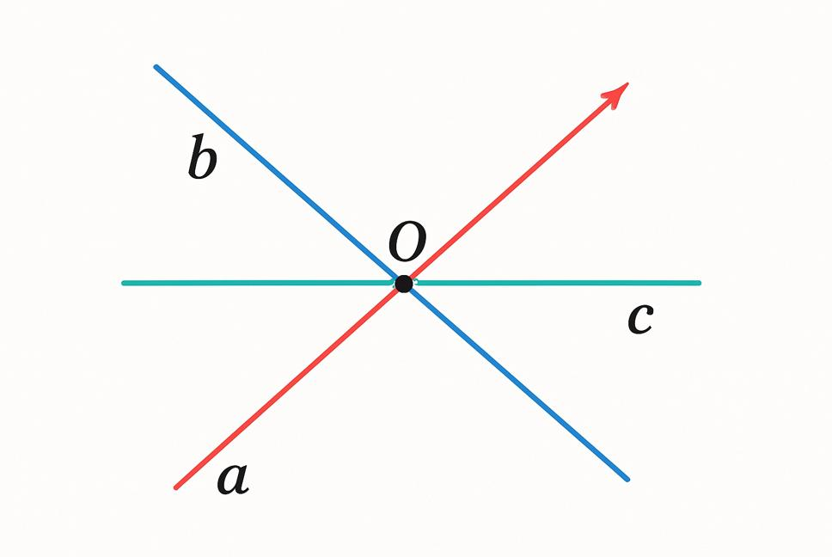
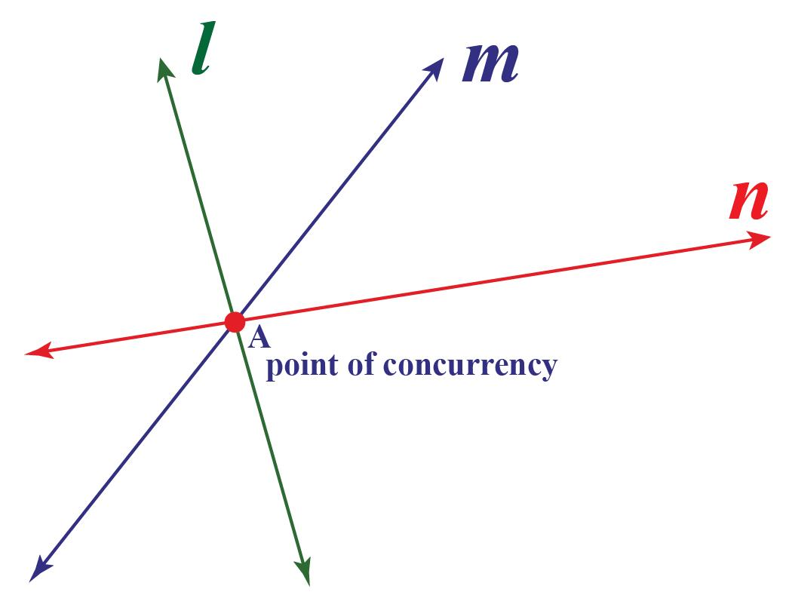
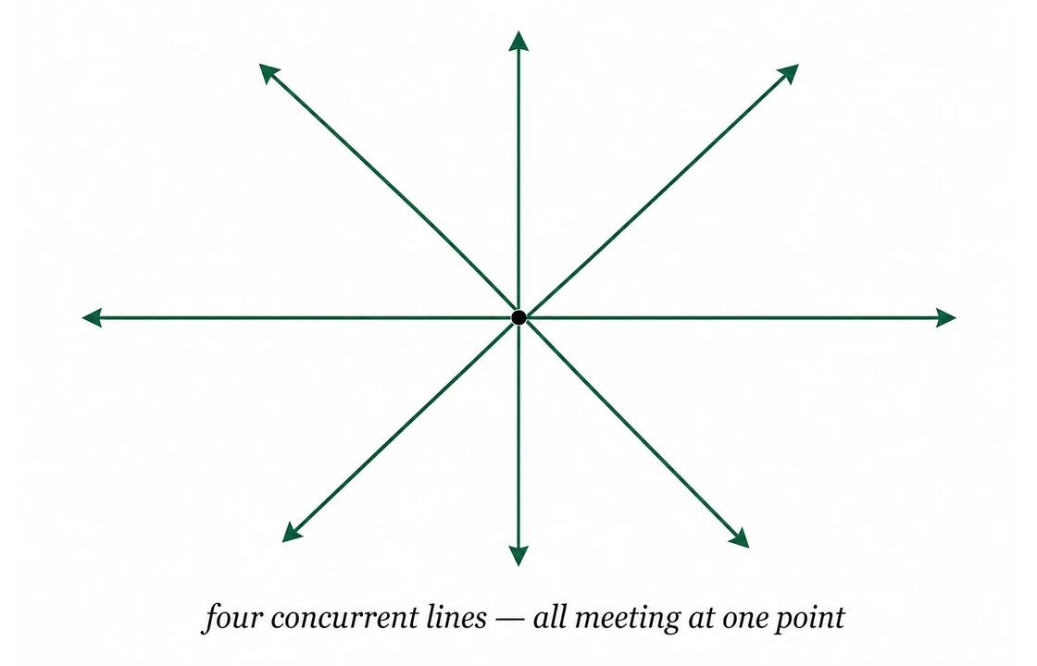
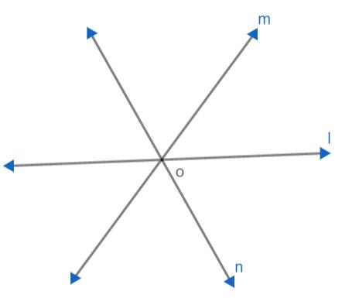
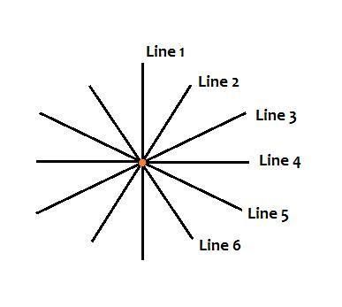

Definition
# Source: AI Source: Provided by: [Data Path: Persons Table -> ID Column: 1, Name_En Column: Motasem Essam] -> From: [ChatGPT] on [7/25/2026]
Concurrent Lines are three or more lines that intersect at a single common point. This common point is called the point of concurrency.
Unlike ordinary intersecting lines, which involve only two lines, concurrent lines require at least three lines meeting at the same point.

Characteristics
# Source: AI Source: Provided by: [Data Path: Persons Table -> ID Column: 1, Name_En Column: Motasem Essam] -> From: [ChatGPT] on [7/25/2026]
Concurrent lines:
- Consist of three or more lines.
- Meet at one common point.
- Form several angles around the point of concurrency.
- Are coplanar in plane geometry.
- May intersect at any angles.

Illustration
# Source: AI Source: Provided by: [Data Path: Persons Table -> ID Column: 1, Name_En Column: Motasem Essam] -> From: [ChatGPT] on [7/25/2026]
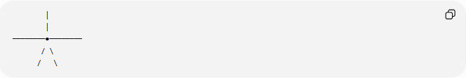
│
│
────────●────────
/ \
/ \
The point ● is the point of concurrency, where all lines meet.

Mathematical Representation
# Source: AI Source: Provided by: [Data Path: Persons Table -> ID Column: 1, Name_En Column: Motasem Essam] -> From: [ChatGPT] on [7/25/2026]
If three lines $l_{1}$, $l_{2}$, and $l_{3}$are concurrent, then:
$$l_{1}∩l_{2}∩l_{3}=P$$
where:
- $P$= point of concurrency.

Examples
# Source: AI Source: Provided by: [Data Path: Persons Table -> ID Column: 1, Name_En Column: Motasem Essam] -> From: [ChatGPT] on [7/25/2026]
Examples of concurrent lines include:
- The three medians of a triangle.
- The three angle bisectors of a triangle.
- The three altitudes of a triangle.
- The three perpendicular bisectors of a triangle.
- Several roads meeting at a roundabout.
- Structural beams meeting at a single joint.

Properties
# Source: AI Source: Provided by: [Data Path: Persons Table -> ID Column: 1, Name_En Column: Motasem Essam] -> From: [ChatGPT] on [7/25/2026]
Concurrent lines:
- Share exactly one common point.
- Involve three or more lines.
- Divide the surrounding plane into multiple angles.
- May intersect at equal or unequal angles.
- Are important in many geometric constructions.

Common Points of Concurrency in a Triangle
# Source: AI Source: Provided by: [Data Path: Persons Table -> ID Column: 1, Name_En Column: Motasem Essam] -> From: [ChatGPT] on [7/25/2026]
Several important sets of lines in a triangle are concurrent:
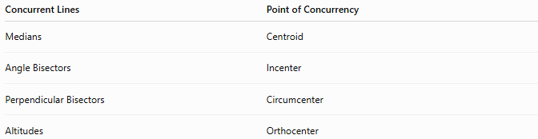
Concurrent Lines | Point of Concurrency
Medians | Centroid
Angle Bisectors | Incenter
Perpendicular Bisectors | Circumcenter
Altitudes | Orthocenter

Applications
# Source: AI Source: Provided by: [Data Path: Persons Table -> ID Column: 1, Name_En Column: Motasem Essam] -> From: [ChatGPT] on [7/25/2026]
Concurrent lines are used in:
- Plane Geometry
- Triangle Geometry
- Coordinate Geometry
- Engineering
- Architecture
- Structural Design
- Construction
- CAD (Computer-Aided Design)
- Surveying
- Computer Graphics

Advantages
# Source: AI Source: Provided by: [Data Path: Persons Table -> ID Column: 1, Name_En Column: Motasem Essam] -> From: [ChatGPT] on [7/25/2026]
Studying concurrent lines helps to:
- Analyze geometric constructions.
- Locate important triangle centers.
- Solve engineering design problems.
- Model structural joints.
- Understand geometric relationships.

Limitations
# Source: AI Source: Provided by: [Data Path: Persons Table -> ID Column: 1, Name_En Column: Motasem Essam] -> From: [ChatGPT] on [7/25/2026]
Concurrent lines:
- Require at least three lines.
- Must all pass through one common point.
- Lose concurrency if one line does not pass through the shared point.

Comparison with Other Types of Lines
# Source: AI Source: Provided by: [Data Path: Persons Table -> ID Column: 1, Name_En Column: Motasem Essam] -> From: [ChatGPT] on [7/25/2026]
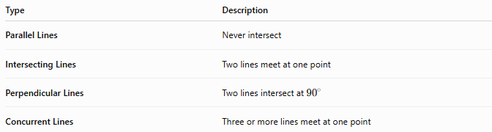
Type | Description
Parallel Lines | Never intersect
Intersecting Lines | Two lines meet at one point
Perpendicular Lines | Two lines intersect at ${90}^{∘}$
Concurrent Lines | Three or more lines meet at one point

Key Points
# Source: AI Source: Provided by: [Data Path: Persons Table -> ID Column: 1, Name_En Column: Motasem Essam] -> From: [ChatGPT] on [7/25/2026]
- Concurrent Lines are three or more lines that intersect at one common point.
- The common point is called the point of concurrency.
- Many important lines in a triangle are concurrent.
- Concurrent lines are fundamental in geometry, engineering, architecture, construction, CAD, and structural design.

Conclusion
# Source: AI Source: Provided by: [Data Path: Persons Table -> ID Column: 1, Name_En Column: Motasem Essam] -> From: [ChatGPT] on [7/25/2026]
Concurrent Lines are three or more lines that intersect at a single common point known as the point of concurrency. They are especially significant in triangle geometry, where the medians, angle bisectors, altitudes, and perpendicular bisectors each meet at important geometric centers. Concurrent lines are widely applied in plane geometry, coordinate geometry, engineering, architecture, construction, surveying, CAD, structural analysis, and computer graphics, where common intersection points are essential for geometric design, structural stability, and spatial analysis.

